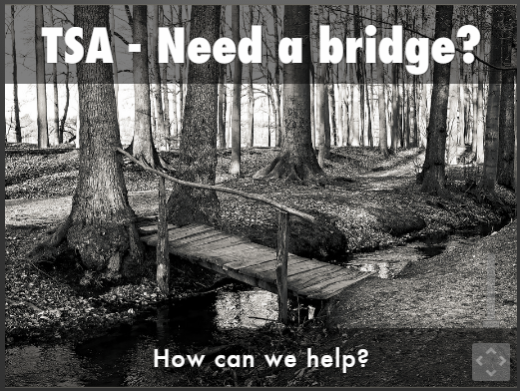 | TSA – Need a bridge?  TSA is a non-profit organization dedicated to fostering an appreciation of storytelling as:  - an oral tradition  - a performing art  - an educational tool
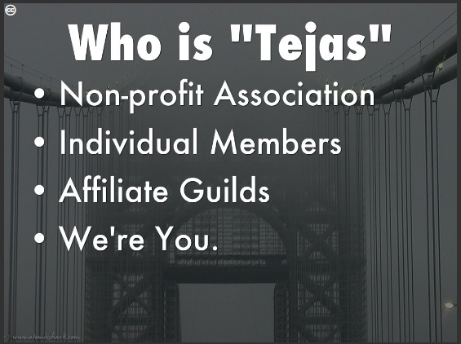 | Who is “TSA”  - Non-profit organization founded in 1985  - 12 Affiliate Guilds  - 3 Affiliate Organizations  - Members from 19 states  - We’re a compilation of tellers, listeners, professionals, amateurs, companies, organizations, individuals, and regular folks  - We’re you.
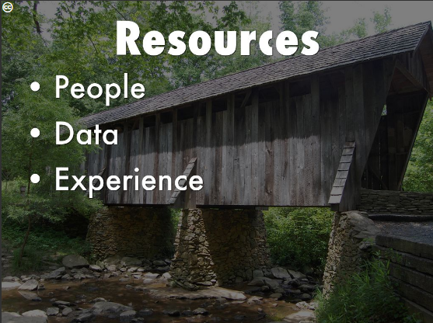 | Resources  - People  - 283 members and growing monthly  - Eclectic variety of people  - Data  - Enhanced recordkeeping  - Enhanced ability to use available data  - We control the data ourselves  - You can make changes yourself  - Experience  - Program experience  - Development experience  - Hundred Thousand stories to share
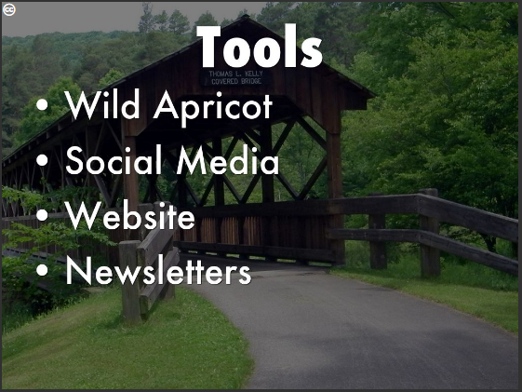 | Tools  - Wild Apricot  - Membership tracking  - Data reporting  - Membership communication  - Social Media  - Twitter - @TejasTales  - Facebook  - Survey Monkey  - Website  - www.tejasstorytelling.com  - Newsletters  - Quarterly Tejas Teller produced by the TSA Board  - Tag-a-longs – delivering program information between Teller editions
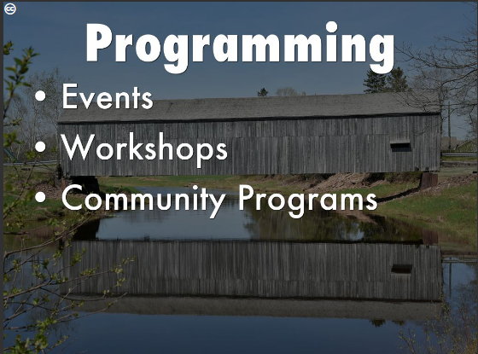 | Programming  - Events  - Annual Festival  - Bi-annual Conference  - Workshops  - During festival  - During Conference  - Guild workshop presenters  - Community Programs  - This is new for TSA
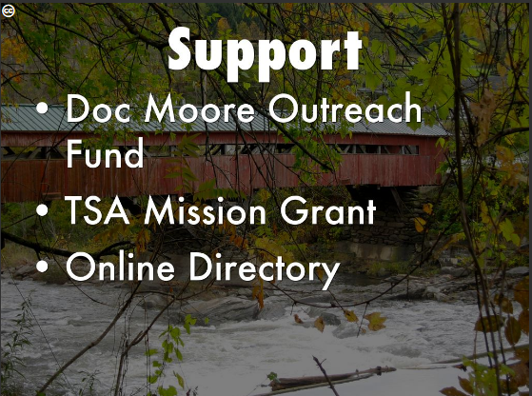 | Support  - Doc Moore Educational Outreach Fund  - Helping make a better Guild  - Online application available  - TSA Mission Grant Program  - Money available for Affiliate Guild programming  - New program for TSA  - Direct community impact  - Online Directory  - Available to TSA members  - Visible on website and on Wild Apricot
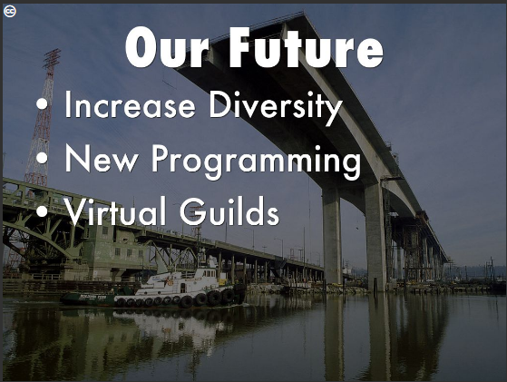 | Our Future  - Increase Diversity  - Membership diversity  - Event attendance  - Guild membership  - New Programming  - Denton Specific programming  - Veterans programs  - High Schools involved in Tellers-in-Schools  - Virtual Guild
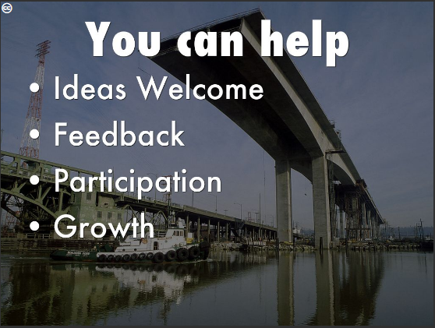 | You Can Help  - Ideas welcome  - tejasprez@gmail.com  - Feedback welcome  - tejasprez@gmail.com  - Participation  - Diversity ideas  - Volunteer coordinator for the Board  - We’ll find something for you to do  - Growth  - New guild possibilities

View this presentation at: https://www.haikudeck.com/tsa---need-a-bridge-education-presentation-8f95e4a7aa#slide0 Download this handout:

Additional Helpful Information

Tools:
- Wild Apricot – http://www.tsa23.wildapricot.org
- Social Media
  - Twitter - @TejasTales
  - Facebook main page – http://www.facebook.com/Tejas.Storytelling
  - Facebook Festival page – http://www.facebook.com/TSAFestival
- Website – http://www.tejasstorytelling.com

Board members:
Larry Thompson | lthompson551@gmail.com | President
Rebba Raine Teller | rebbaraine@icloud.com | Vice President
Granville Ott | gott_austin@yahoo.com | Treasurer
Sue Kuentz | sue.kuentz@gmail.com | Secretary
Mary Margaret Campbell | marymargaret@georgeweststoryfest.org | Nominating Committee; Awards Committee
Kim Lehman | kim.lehman@sbcglobal.net | Public Relations and Marketing
Leslie Buie | lesliebuie@aol.com | Volunteer Coordinator
Reba Ott | gott_austin@yahoo.com | Member at Large
Mel Davenport | luvandstories@aol.com | Member at Large
James West | james@commoncompany.org | Member at Large
Kay Tobola | tejasstories2tell@gmail.com | Festival Managing Director

